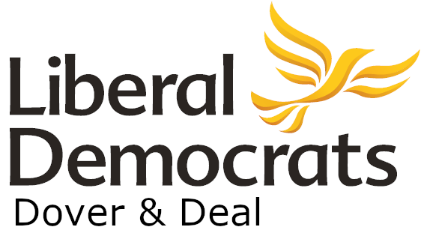

ANNUAL GENERAL MEETING
DOVER & DEAL LIBERAL DEMOCRATS

ROYAL HOTEL, DEAL, CT14 6JD
SATURDAY NOVEMBER 22, 2025 AT 10.30AM

AGENDA

Apologies

- Minutes of previous Annual General Meeting, held on November 16, 2024.

- Reports from:
- Chair
- Treasurer
- Membership Report
- Liberal Democrat Groups from:
- Sandwich Town Council
- Walmer Town Council

- Election of Honorary President

- Election of Officers and Executive Committee Members*

- To note the Accounts for 2024

- Appointment of Independent Examiner for the 2025 Local Party Accounts

* See nomination form, attached, for details of post-holders needed.

After the formal meeting Cllr Alex Ricketts, Deputy Leader for the Liberal Democrat Group and Cabinet Member for Tourism, Transport, Oversight and Performance and Rural Champion on Canterbury City Council
will speak about how to challenge Reform in Kent.

Printed and published by Martyn Pennington, 1 Elizabeth Drive, Woodnesborough, Sandwich, CT13 0FR

